Aim: - To implement and observe output of Linear and Non-Linear SVM.

CODE: -

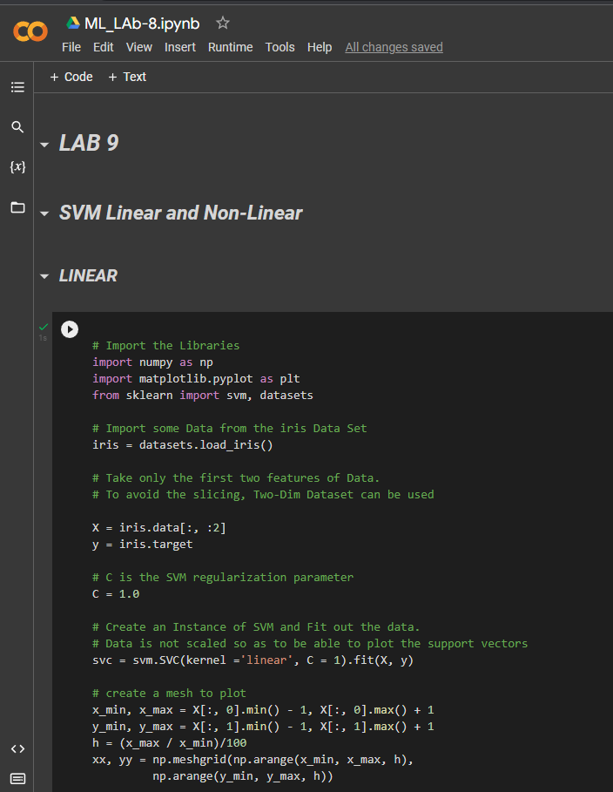

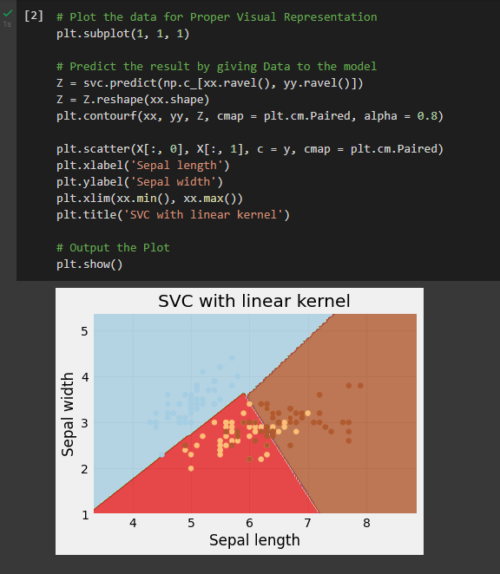

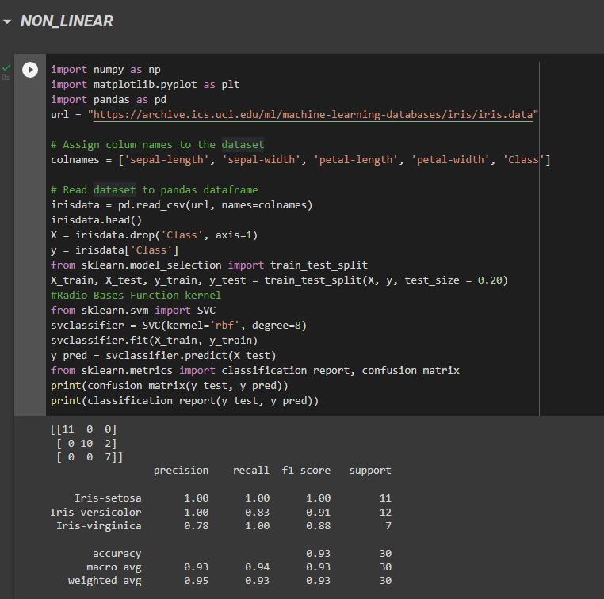

Result: -

Hence Verified and got the output of the tasks on the Google Colab.